# Q.1) Write a Python program which accepts the user's first and last name and print them in # reverse order with a space between them.
first_name = input("Enter your first name: ")
last_name = input("Enter your last name: ")
print(f"{last_name} {first_name}")

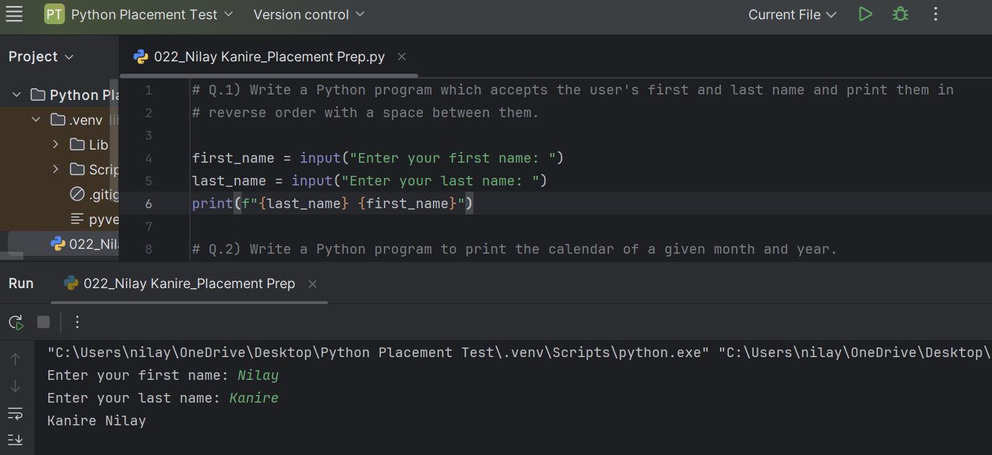
# Q.2) Write a Python program to print the calendar of a given month and year.
# Note : Use 'calendar' module.
import calendar
year = int(input("Enter year (e.g., 2023): "))
month = int(input("Enter month (1-12): "))
print(calendar.month(year, month))
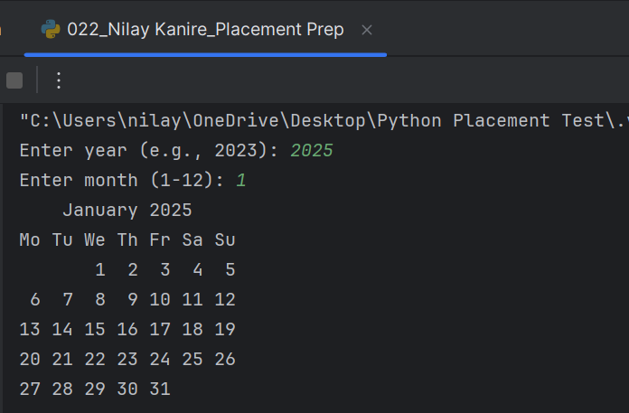
# Q.3) Write a Python program to calculate number of days between two dates.
# [ use datetime module ]
# Sample dates : (2014, 7, 2), (2014, 7, 11)
# Expected output : 9 days
from datetime import *
past_date = datetime(2014, 7, 2)
future_date = datetime(2014, 7, 11)
print(future_date - past_date)
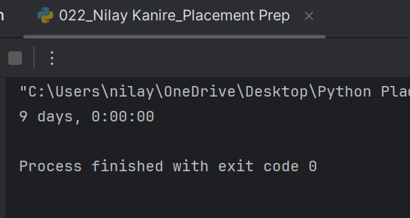

# Q.4) Write a Python program to test whether a passed letter is a vowel or not.
vowel = [ 'A', 'a', 'E', 'e', 'I', 'i', 'O', 'o', 'U', 'u']
letter = input("Enter the letter to check if it is vowel or not : ")[0]
for i in vowel:
if(i == letter):
print("It is an Vowel")
break
else:
print("It is not an Vowel")
